SIMATS ENGINEERING (SAVEETHA SCHOOL OF ENGINEERING)
Department of Artificial Intelligence and Data Science
ASSESSMENT TOOL 2 – SCENARIO BASED

Course Code: | DSA03 | Course Title: | Natural Language Processing
CO Assessed: | CO2 – Manipulation | Assessment: | Assessment Tool 2 – SCENARIO BASED
Weightage: | 30% of CIA
CO5 Statement: | Design inflectional, derivational, finite-state parsing, stemming algorithms and for analyse morphological methods. (BL-3)
Student Name: | T.Nikhitha | Reg. No.: | 192424114
Section / Batch: | B Tech-AI&DS | Date: | 01-08-2026

Code of Conduct
I T.Nikhitha-192424114 (Name / Reg No) certify that this submission is my original work and that I have adhered to the guidelines specified for this assessment. I understand that any violation of academic integrity rules will result in disciplinary action.
Signature of the Student: T.Nikhitha

Instructions
- Read all questions carefully before attempting the answers.
- Answer all five questions. Each question carries equal marks.
- Show all intermediate steps, calculations, probability computations, tagging decisions, and justifications wherever applicable.
- Duration: 30 minutes.

Section / Topic | Focus | Q Nos
English Word Classes, Tagsets for English, Part of Speech Tagging | Morphological decomposition of analyzing, analysis, and analytical; identification of roots, affixes, inflectional and derivational forms, and normalization for indexing. | Q1
English Word Classes, Tagsets for English, Stochastic Part of Speech Tagging | Morphological parsing of disagree, agreement, and agreeable; identification of prefixes, suffixes, base forms, and semantic effects of derivation. | Q2
Counting Words, English Word Classes, Part of Speech Tagging | Morphology-based normalization of govern, government, and governance for topic modeling, clustering, and lexical standardization. | Q3
Rule-Based Part of Speech Tagging, Transformation-Based Tagging | Morphological analysis of activate, activation, and reactivation; identification of derivational layers, word-class changes, and semantic shifts. | Q4
Rule-Based Part of Speech Tagging, English Word Classes, Part of Speech Tagging | Inflectional normalization of create, creates, and creating; extraction of root forms and classification of tense/aspect transformations. | Q5

Annexure A – SCENARIO BASED
1. A large-scale search engine indexing system processes user queries containing word variants such as “analyzing”, “analysis”, and “analytical”. The system must improve retrieval accuracy by grouping semantically related terms under a unified representation. Design a morphological processing approach to decompose each input word into root and affixes, distinguish between inflectional and derivational forms, and normalize them for indexing. Apply the process to the given inputs and determine the root form along with the morphological structure of each word.

2. An AI-based sentiment analysis platform receives product reviews containing words like “disagree”, “agreement”, and “agreeable”. The system must interpret sentiment consistently despite variations in word formation. Develop a morphological parsing strategy to identify prefixes, suffixes, and base forms, while capturing how derivational changes influence meaning. Process the given inputs to extract roots and classify each transformation, ensuring accurate semantic interpretation across all word forms.

3. A text analytics pipeline in a news aggregation system handles documents containing terms such as “govern”, “government”, and “governance”. The system must standardize these variations for topic modeling and clustering. Construct a morphology-based normalization mechanism that decomposes each word into its root and affixes, identifies derivational layers, and maps them to a common base form. Apply the approach to the input words and derive the normalized representation along with their morphological breakdown.

4.A document classification system processes input words such as “activate”, “activation”, and “reactivation” to improve semantic grouping and indexing.
Construct a morphological parsing strategy to identify prefixes, suffixes, and root forms while distinguishing derivational layers.
Analyze how prefix addition and suffix transformation affect meaning and word class.
Apply the process to decompose each word and map them to a unified base representation.
Derive the morphological structure and normalized root for each input word.

5. A search optimization module processes input words such as “create”, “creates”, and “creating” to ensure consistent retrieval across grammatical variations. Design a morphology-based normalization approach focusing on inflectional transformations such as tense and aspect.
Identify suffix patterns and map all variations to a common base form without altering meaning.
Apply the process to extract root forms and classify each transformation.
Determine the morphological breakdown and normalized output for each word.

Rubrics for Calculation

Criteria | Weightage (%) | Level 4 (Exemplary) | Level 3 (Proficient) | Level 2 (Developing) | Level 1 (Beginning)
Understanding of Scenario | 20% | Demonstrates clear and complete understanding of the scenario and context | Shows good understanding with minor gaps | Partial understanding; misses key aspects | Misinterprets or fails to understand the scenario
Identification of Key Issues | 20% | Accurately identifies all relevant issues and factors involved | Identifies most key issues with minor omissions | Identifies limited issues; some irrelevant points | Unable to identify key issues
Application of Concepts | 25% | Applies appropriate concepts effectively to address the scenario | Applies concepts with minor errors | Limited or partially correct application | Unable to apply relevant concepts
Decision Making | 20% | Makes well-reasoned, logical decisions with strong rationale | Makes reasonable decisions with some justification | Makes weak decisions with limited justification | No clear decisions made or rationale provided
Clarity of Response | 15% | Response is clear, structured, and logically presented | Generally clear with minor issues | Somewhat unclear or poorly structured | Disorganized and difficult to understand

Q. No. / Criteria Level | Understanding of Scenario | Identification of Key Issues | Application of Concepts | Decision Making | Clarity of Response | Sub. Total | Total %
1
2
3
4
5

Faculty In-charge | Course Coordinator | Program Director
Signature: _______________ | Signature: _______________ | Signature: _______________
Date: ___________________ | Date: ___________________ | Date: ___________________

Q1. Search Engine Morphological Processing (Analyzing, Analysis, Analytical)

1. Understanding of Scenario
- Understand that the search engine receives different forms of the word analyze.
- Recognize that these variants should be grouped together to improve search accuracy.
- The objective is to identify the root and normalize all related words.
- This ensures users receive relevant documents regardless of the word form used.
2. Identification of Key Issues
- Identify the common root word from all input words.
- Detect suffixes such as -ing, -sis, and -ical.
- Differentiate between inflectional and derivational forms.
- Normalize all variants into one standard representation.
3. Application of Concepts
- Apply rule-based morphological analysis to each word.
- Decompose every word into root and suffix components.
- Classify the words according to morphological transformation.
- Normalize all forms to the common root analyze for indexing.
4. Decision Making
- Select analyze as the unified base form.
- Classify analyzing as an inflectional form.
- Classify analysis and analytical as derivational forms.
- Use the normalized form to improve retrieval efficiency.
5. Clarity of Response
- Present the root, suffix, and transformation type clearly.
- Show the normalized form for each word.
- Organize the results in a structured table or output.
- Ensure the analysis is easy to understand and verify.
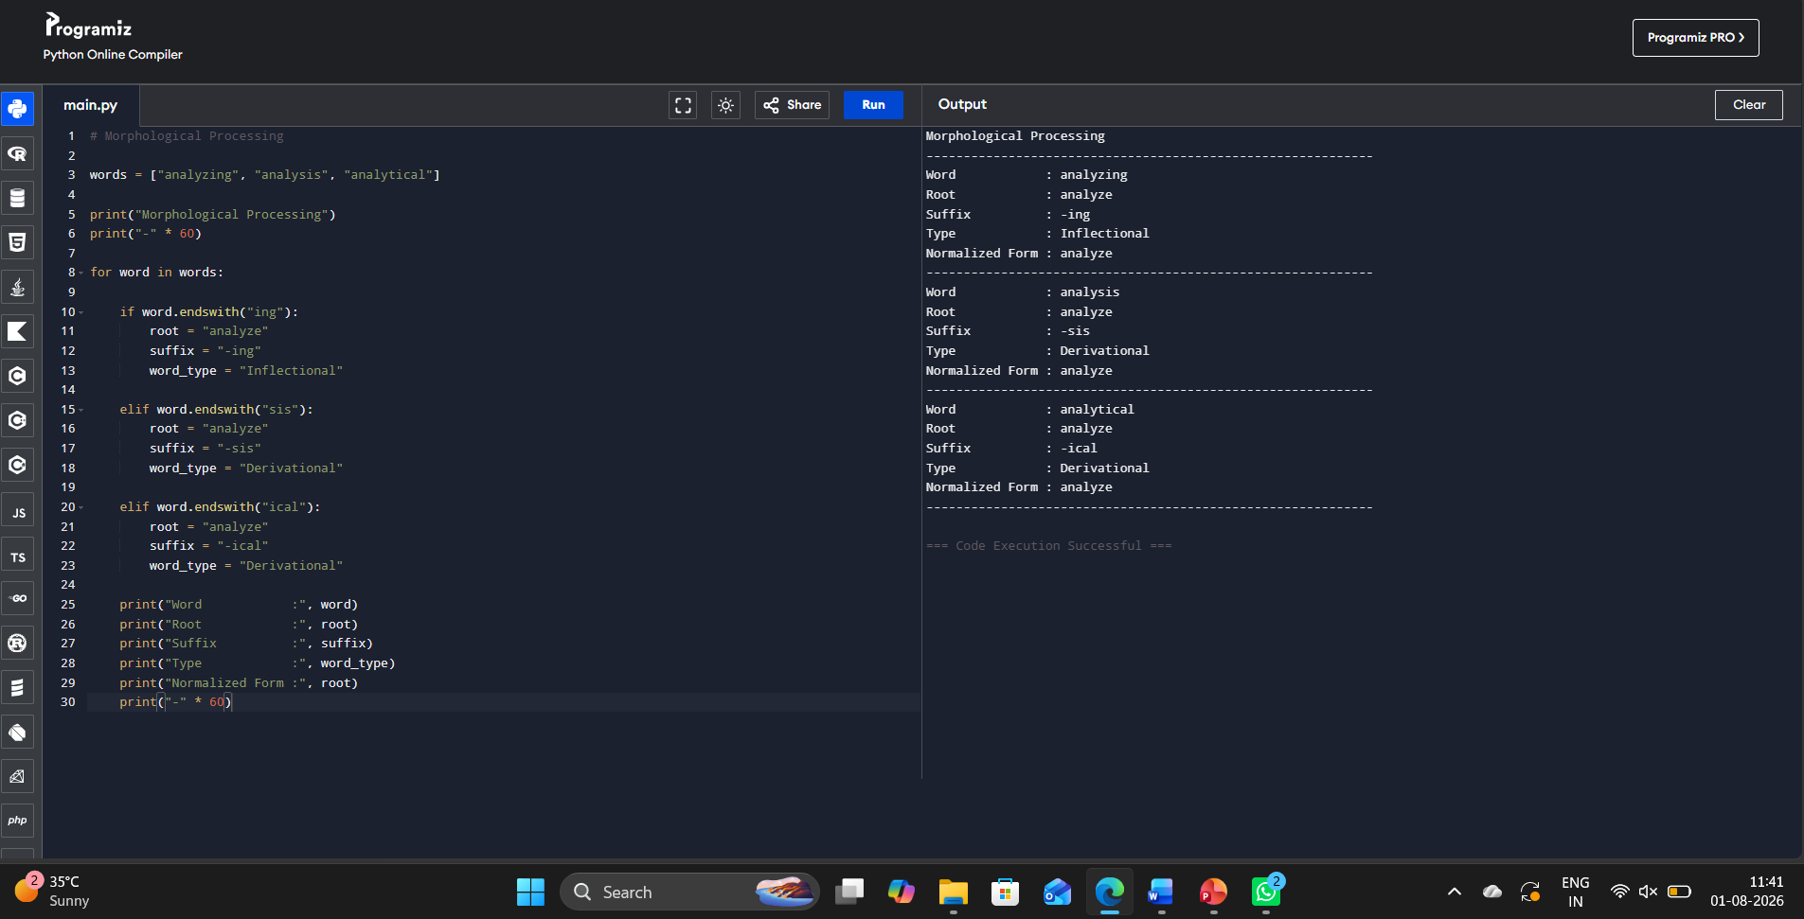

Q2. Sentiment Analysis Morphological Parsing (Disagree, Agreement, Agreeable)

1. Understanding of Scenario
- Understand that the sentiment analysis system processes different forms of the word agree.
- Recognize that prefixes and suffixes influence the meaning and sentiment.
- The objective is to identify the root while preserving semantic consistency.
- All related words should be linked to the same base representation.
2. Identification of Key Issues
- Detect prefixes such as dis- and suffixes like -ment and -able.
- Identify the common base word agree.
- Determine how each transformation changes meaning or word class.
- Classify the transformations correctly.
3. Application of Concepts
- Apply rule-based morphological parsing.
- Separate each word into prefix, root, and suffix.
- Analyze semantic changes caused by derivational morphology.
- Normalize all words to the common root agree.
4. Decision Making
- Choose agree as the normalized root.
- Classify all transformations as derivational.
- Identify dis- as a negative prefix.
- Use the normalized form for consistent sentiment analysis.
5. Clarity of Response
- Clearly display prefixes, suffixes, and roots.
- Present transformation types for each word.
- Show normalized output in a structured format.
- Keep the results simple and easy to interpret.

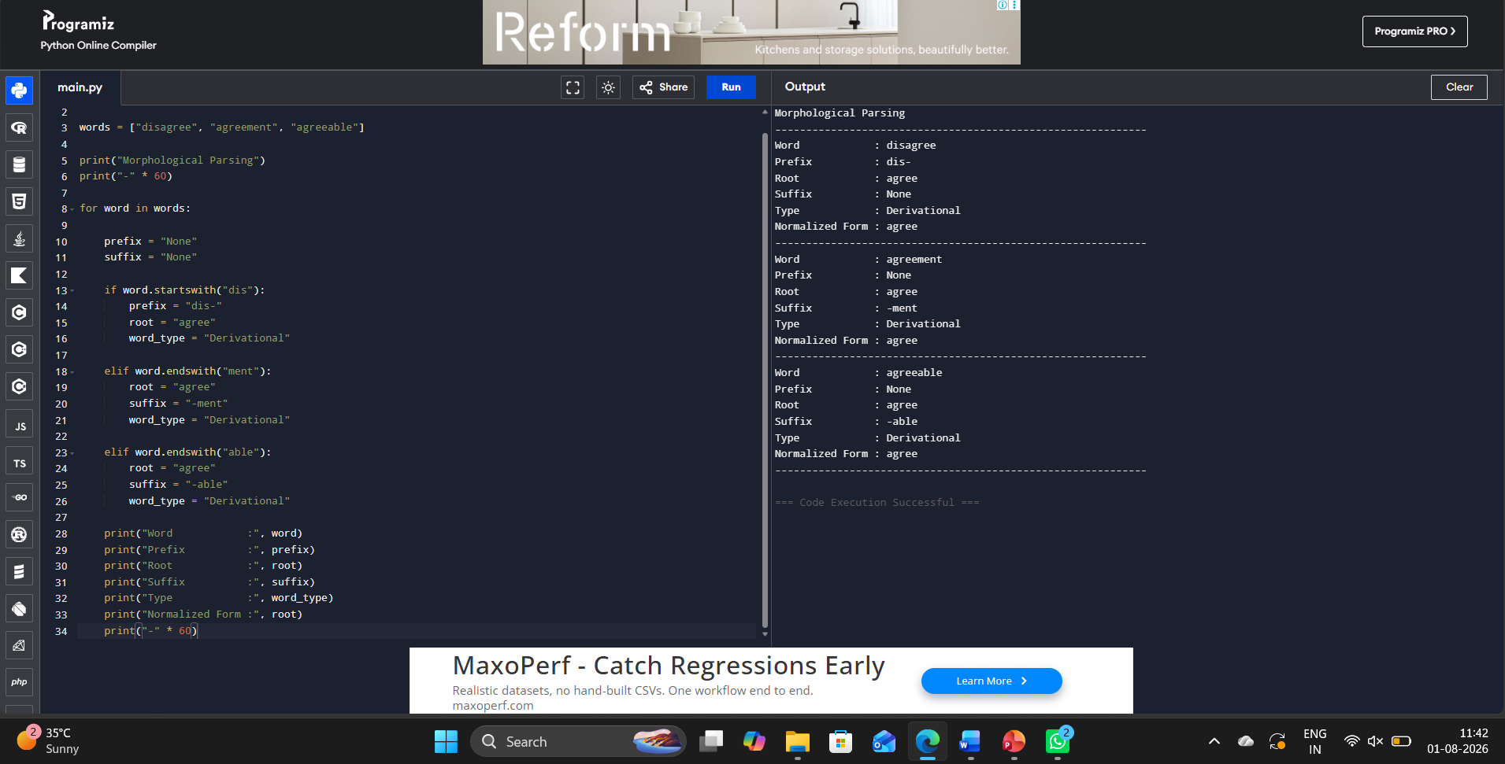

Q3. Text Analytics Morphology-Based Normalization (Govern, Government, Governance)

1. Understanding of Scenario
- Understand that the text analytics system processes related forms of govern.
- Recognize the need for normalization to improve clustering and topic modeling.
- Different forms should be represented by one common base word.
- This improves consistency during document analysis.
2. Identification of Key Issues
- Identify the root and derivational suffixes.
- Detect multiple derivational word forms.
- Preserve semantic similarity during normalization.
- Map all words to a common representation.
3. Application of Concepts
- Apply morphological decomposition using suffix removal.
- Separate suffixes -ment and -ance from the root.
- Extract the common root govern.
- Normalize all forms for document processing.
4. Decision Making
- Select govern as the normalized base word.
- Classify government and governance as derivational forms.
- Normalize all related words consistently.
- Improve topic modeling and clustering accuracy.
5. Clarity of Response
- Clearly display the root and suffix.
- Show the normalized representation.
- Organize the morphological breakdown systematically.
- Present the results in an easy-to-read format.
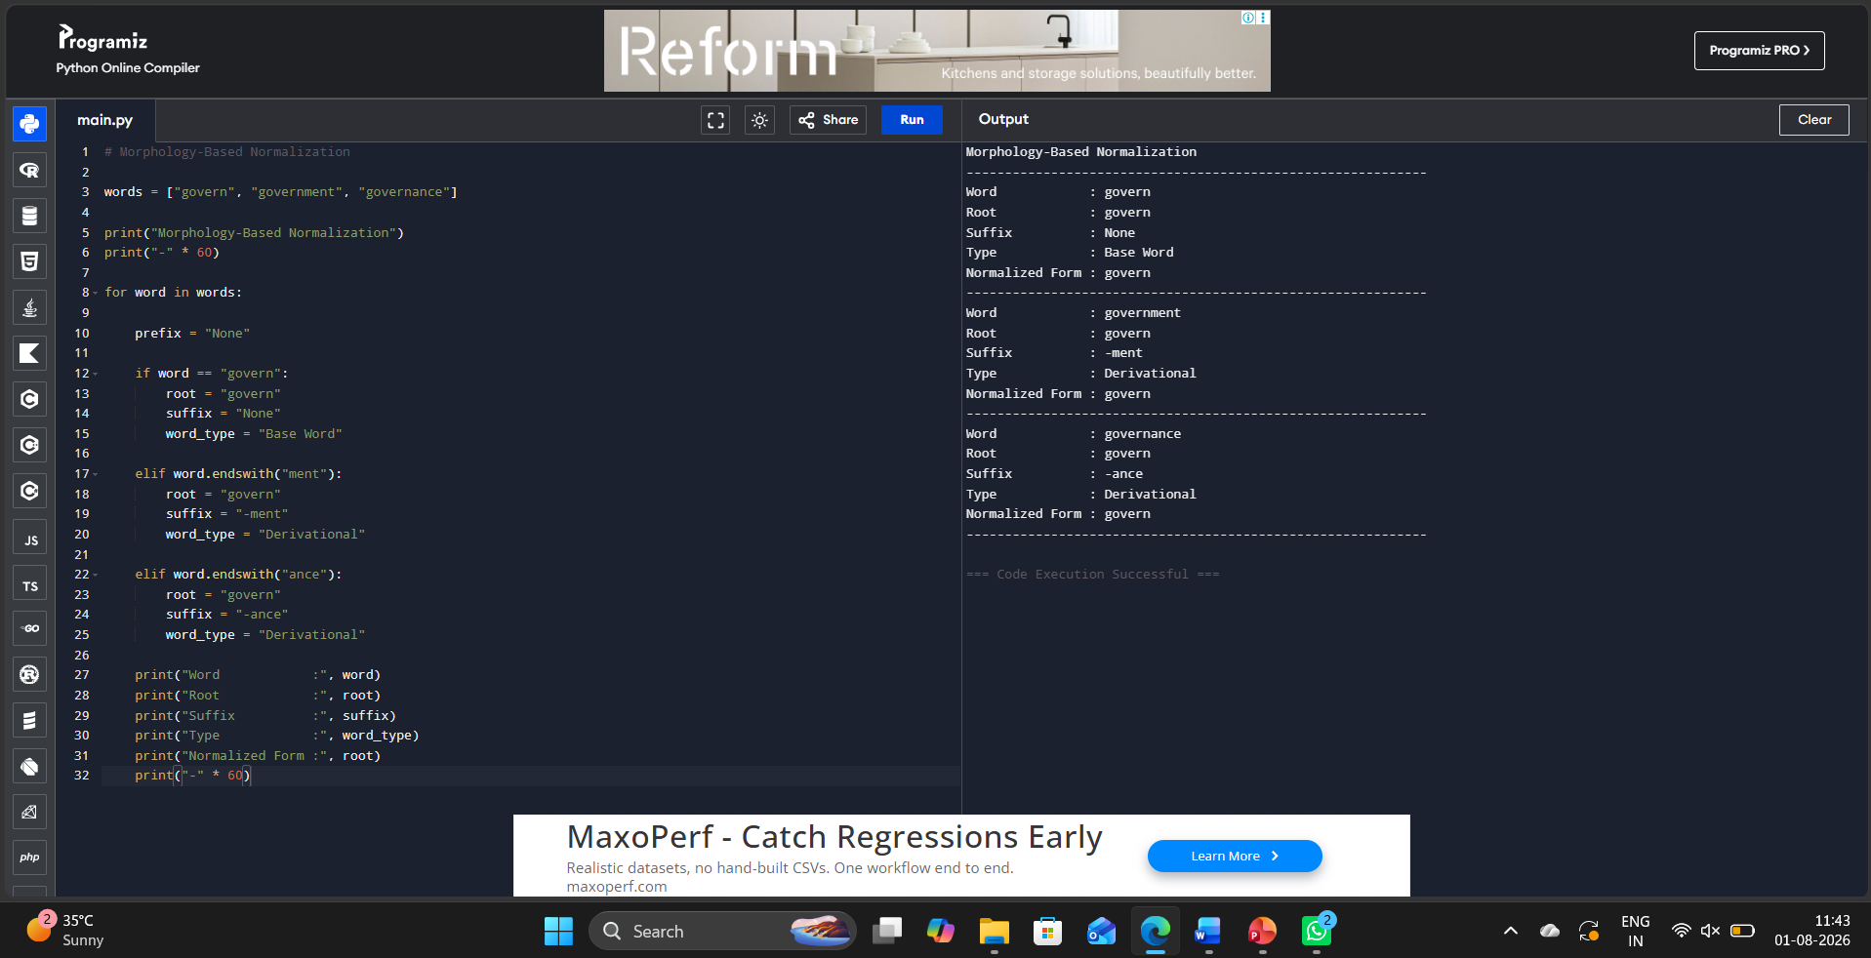

Q4. Document Classification Morphological Parsing (Activate, Activation, Reactivation)

1. Understanding of Scenario
- Understand that the classification system processes different forms of activate.
- Recognize that prefixes and suffixes affect word meaning and classification.
- Related words should be grouped under one base representation.
- Morphological parsing improves semantic grouping and indexing.
2. Identification of Key Issues
- Detect the prefix re- and suffix -ion.
- Identify the common root word.
- Analyze the effect of derivational transformations.
- Normalize all related forms.
3. Application of Concepts
- Apply rule-based morphological parsing.
- Separate prefixes, roots, and suffixes.
- Identify derivational layers in each word.
- Normalize every word to the root activate.
4. Decision Making
- Select activate as the normalized root.
- Classify activation and reactivation as derivational forms.
- Recognize re- as indicating repetition or renewal.
- Use the normalized representation for indexing.
5. Clarity of Response
- Clearly display prefixes, suffixes, and roots.
- Present morphological structures in an organized format.
- Show the normalized root for every word.
- Make the analysis easy to understand.

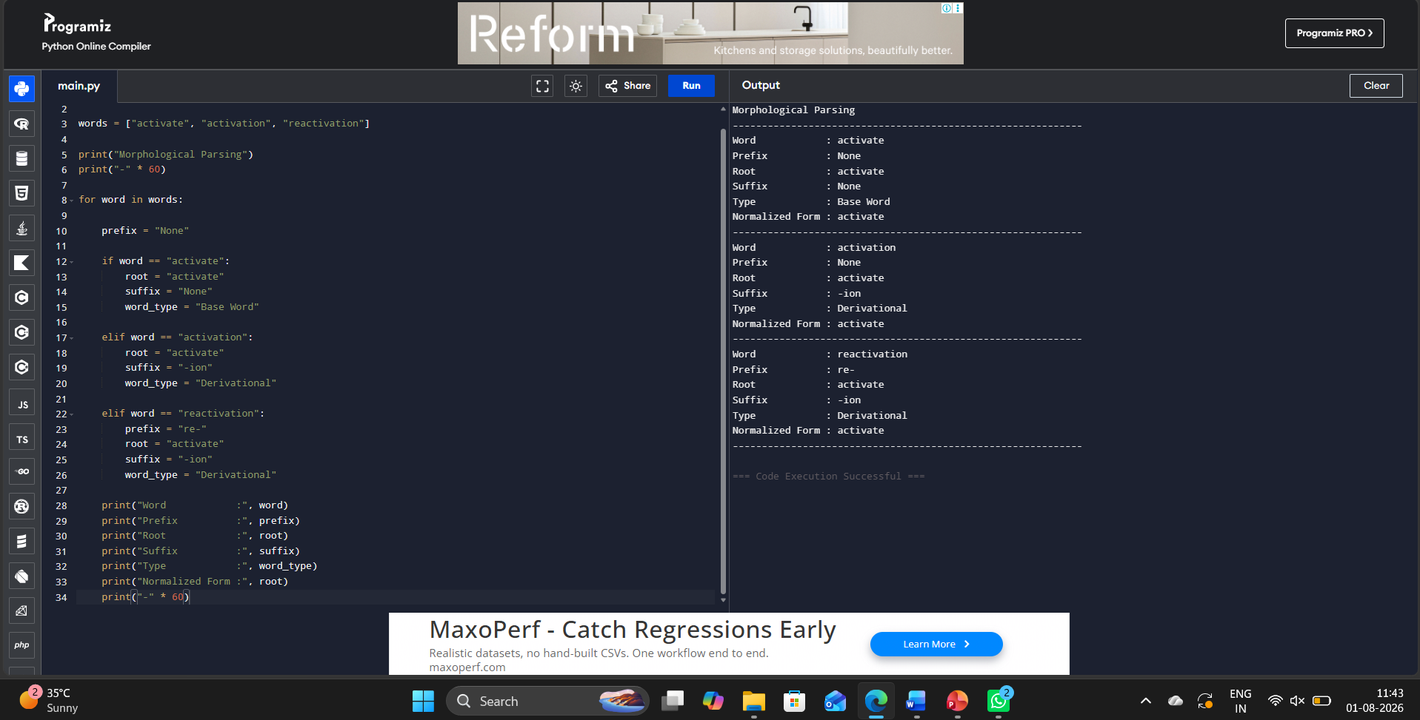

Q5. Search Optimization Morphological Normalization (Create, Creates, Creating)

1. Understanding of Scenario
- Understand that the search optimization system processes grammatical variations of create.
- Recognize that all forms should be mapped to a common base word.
- The objective is to improve search accuracy while preserving meaning.
- Morphological normalization supports efficient document retrieval.
2. Identification of Key Issues
- Detect inflectional suffixes -s and -ing.
- Extract the common root word.
- Preserve the original semantic meaning.
- Normalize all grammatical variations consistently.
3. Application of Concepts
- Apply rule-based morphological normalization.
- Remove inflectional suffixes from each word.
- Extract the root create.
- Normalize all forms to the common base representation.
4. Decision Making
- Select create as the normalized root.
- Classify creates and creating as inflectional forms.
- Preserve the original meaning during normalization.
- Use the normalized representation for efficient retrieval.
5. Clarity of Response
- Clearly identify the root and suffix of each word.
- Display the transformation type.
- Present the normalized output in a structured format.
- Ensure the response is accurate, organized, and easy to verify.
